Test Case: tc005_SPX_Dev5_Crear_Requisicion_Spot_Con_FAD_Tipo_Cobro_Project
Step 1 - Enter username and password and click to button Enter: Credentials Entered
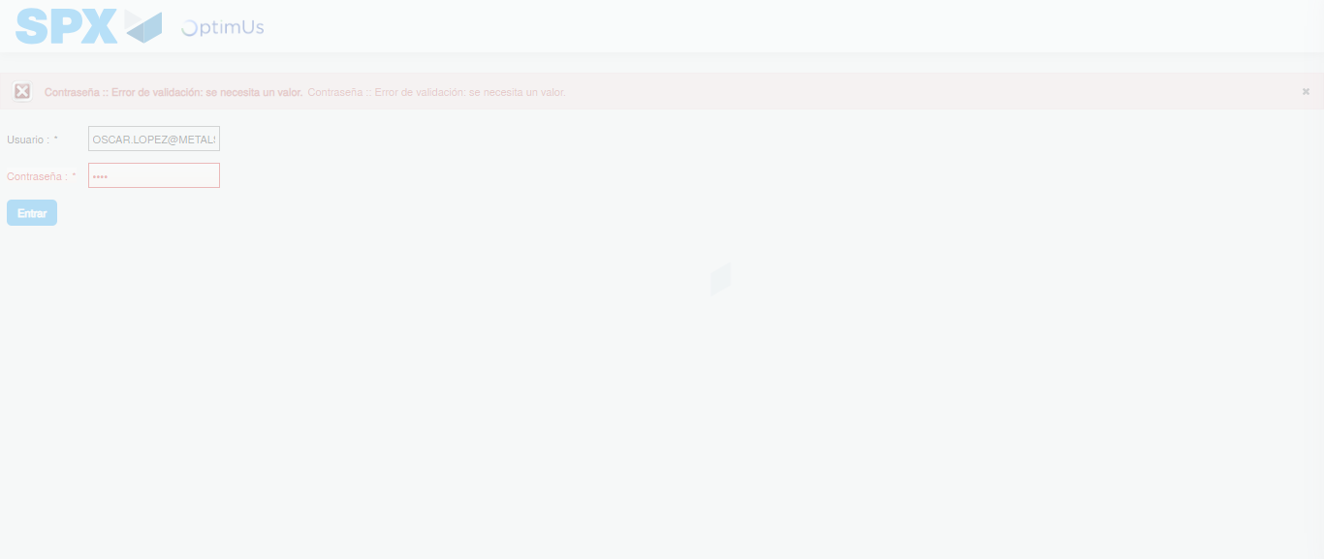Image file-name: QC_Testing-tc005_SPX_Dev5_Crear_Requisicion_Spot_Con_FAD_Tipo_Cobro_Project-1784653166239

Step 2 - Select to UEN and Access to Spot Buy Requisitions : UEN Correctly selected and Correct access
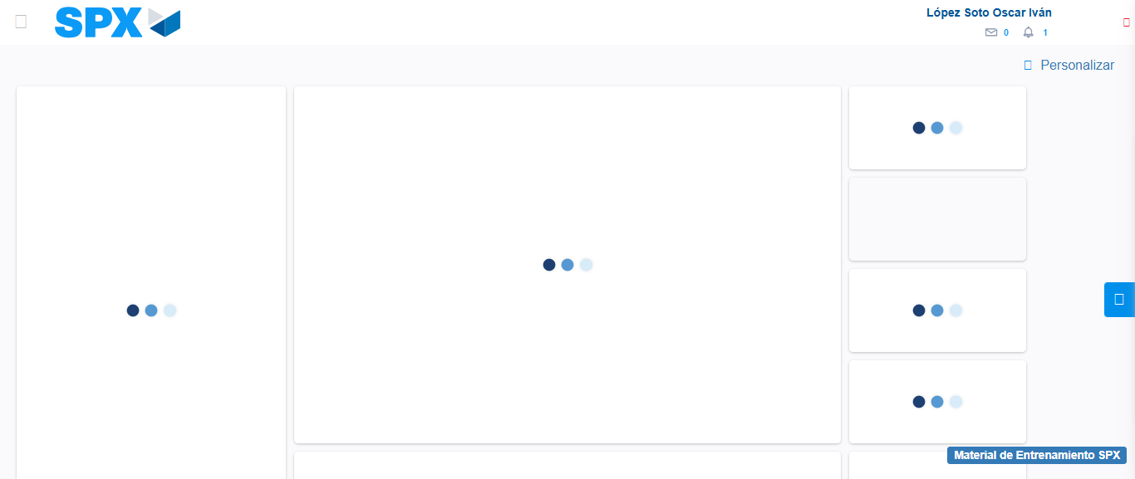Image file-name: QC_Testing-tc005_SPX_Dev5_Crear_Requisicion_Spot_Con_FAD_Tipo_Cobro_Project-1784653192868

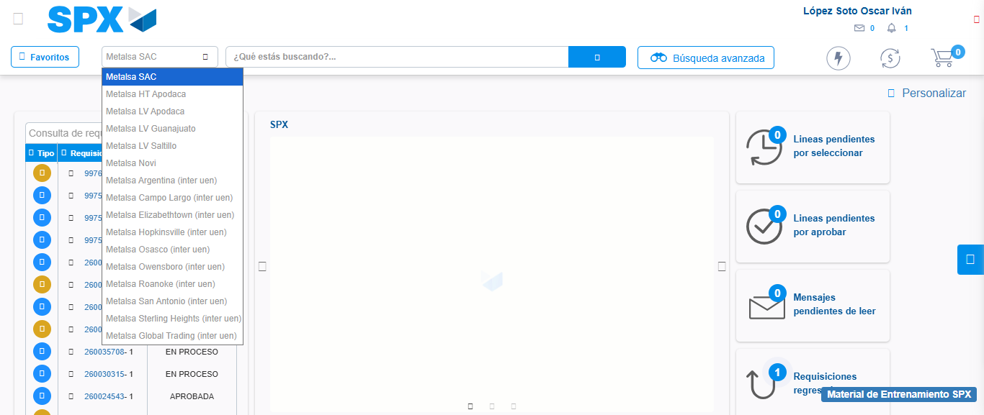Image file-name: QC_Testing-tc005_SPX_Dev5_Crear_Requisicion_Spot_Con_FAD_Tipo_Cobro_Project-1784653206011

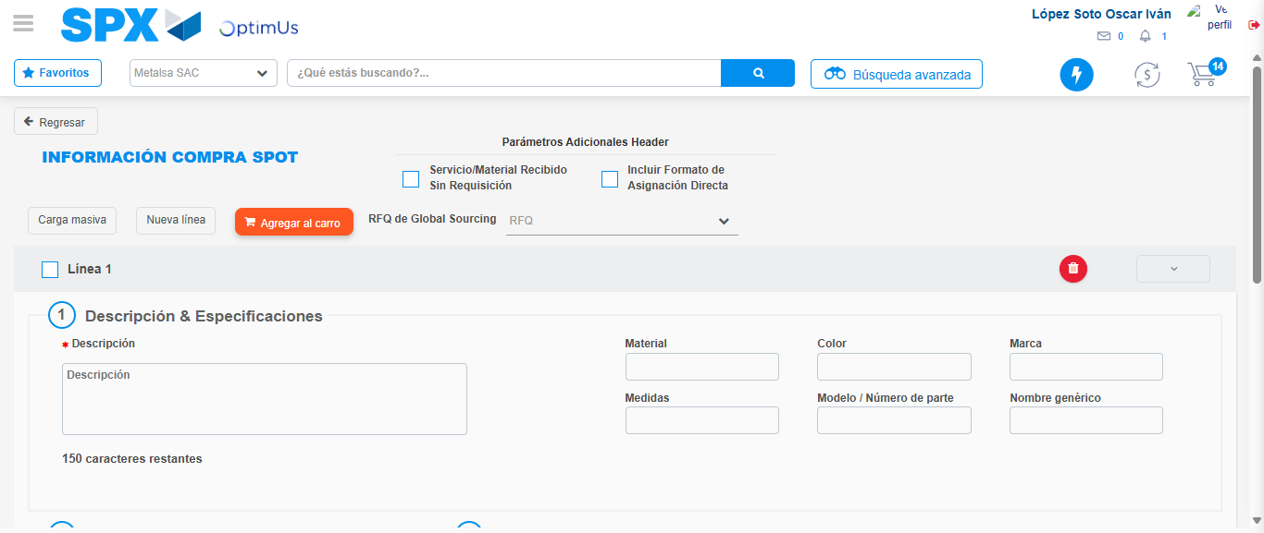Image file-name: QC_Testing-tc005_SPX_Dev5_Crear_Requisicion_Spot_Con_FAD_Tipo_Cobro_Project-1784653215352

Step 3 - Add FAD to Requisition: FAD Successfully Added
Image file-name: QC_Testing-tc005_SPX_Dev5_Crear_Requisicion_Spot_Con_FAD_Tipo_Cobro_Project-1784653215591

Image file-name: QC_Testing-tc005_SPX_Dev5_Crear_Requisicion_Spot_Con_FAD_Tipo_Cobro_Project-1784653215813

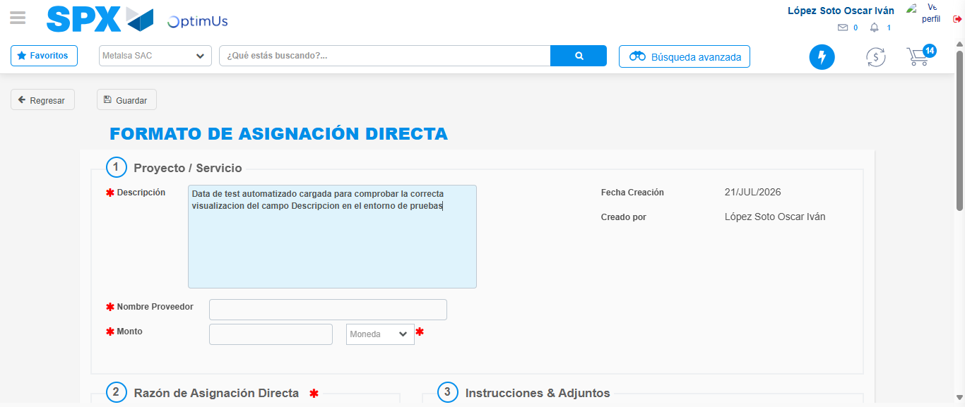Image file-name: QC_Testing-tc005_SPX_Dev5_Crear_Requisicion_Spot_Con_FAD_Tipo_Cobro_Project-1784653218779

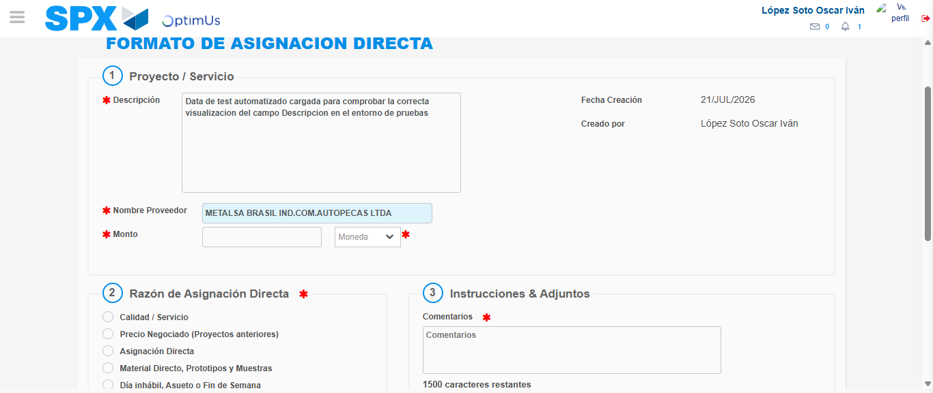Image file-name: QC_Testing-tc005_SPX_Dev5_Crear_Requisicion_Spot_Con_FAD_Tipo_Cobro_Project-1784653225296

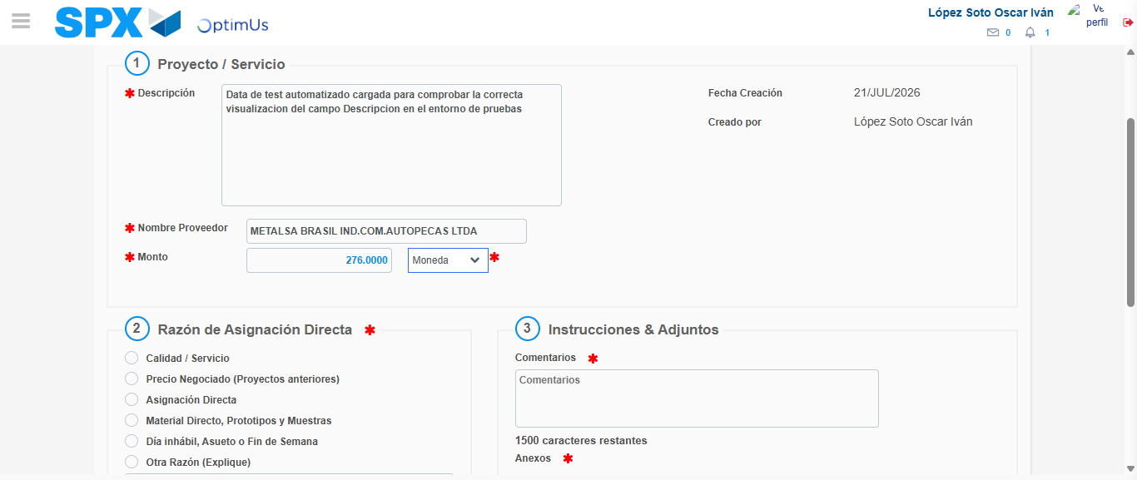Image file-name: QC_Testing-tc005_SPX_Dev5_Crear_Requisicion_Spot_Con_FAD_Tipo_Cobro_Project-1784653225765

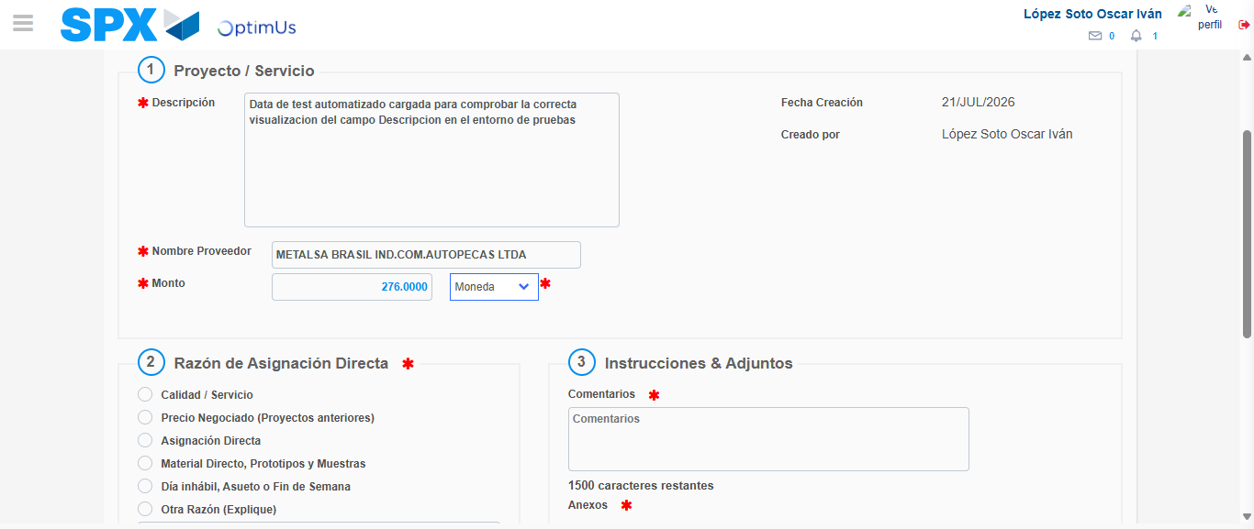Image file-name: QC_Testing-tc005_SPX_Dev5_Crear_Requisicion_Spot_Con_FAD_Tipo_Cobro_Project-1784653226022

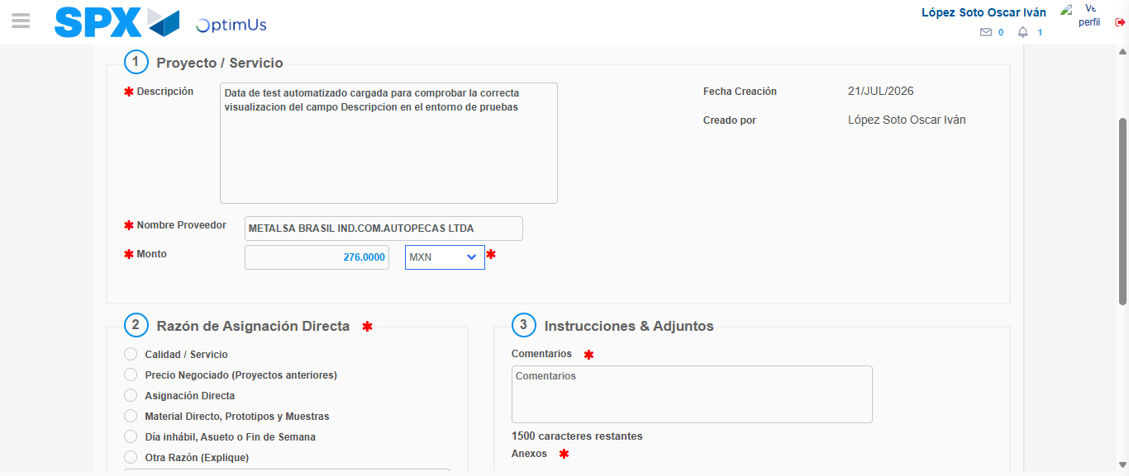Image file-name: QC_Testing-tc005_SPX_Dev5_Crear_Requisicion_Spot_Con_FAD_Tipo_Cobro_Project-1784653226441

Image file-name: QC_Testing-tc005_SPX_Dev5_Crear_Requisicion_Spot_Con_FAD_Tipo_Cobro_Project-1784653226673

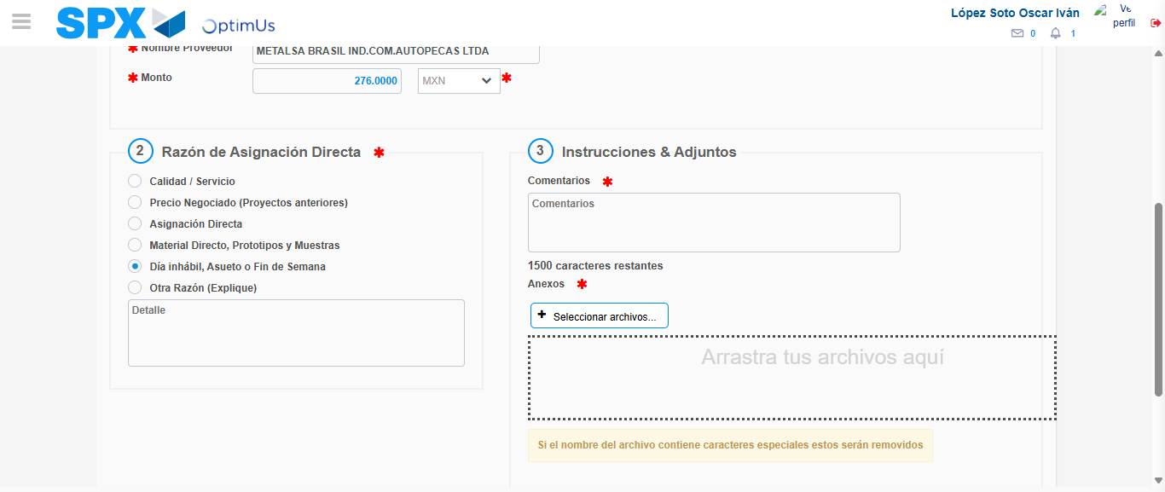Image file-name: QC_Testing-tc005_SPX_Dev5_Crear_Requisicion_Spot_Con_FAD_Tipo_Cobro_Project-1784653227613

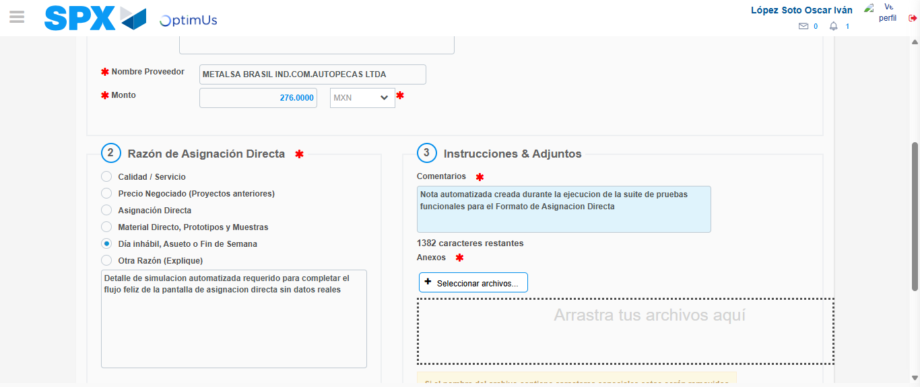Image file-name: QC_Testing-tc005_SPX_Dev5_Crear_Requisicion_Spot_Con_FAD_Tipo_Cobro_Project-1784653238888

Image file-name: QC_Testing-tc005_SPX_Dev5_Crear_Requisicion_Spot_Con_FAD_Tipo_Cobro_Project-1784653239692

Step 4 - Data Capture Spot Buy Requisition: Data captured correctly
Image file-name: QC_Testing-tc005_SPX_Dev5_Crear_Requisicion_Spot_Con_FAD_Tipo_Cobro_Project-1784653215591

Image file-name: QC_Testing-tc005_SPX_Dev5_Crear_Requisicion_Spot_Con_FAD_Tipo_Cobro_Project-1784653215813

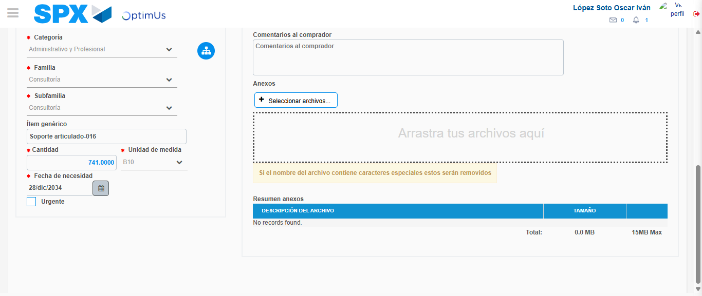Image file-name: QC_Testing-tc005_SPX_Dev5_Crear_Requisicion_Spot_Con_FAD_Tipo_Cobro_Project-1784653253033

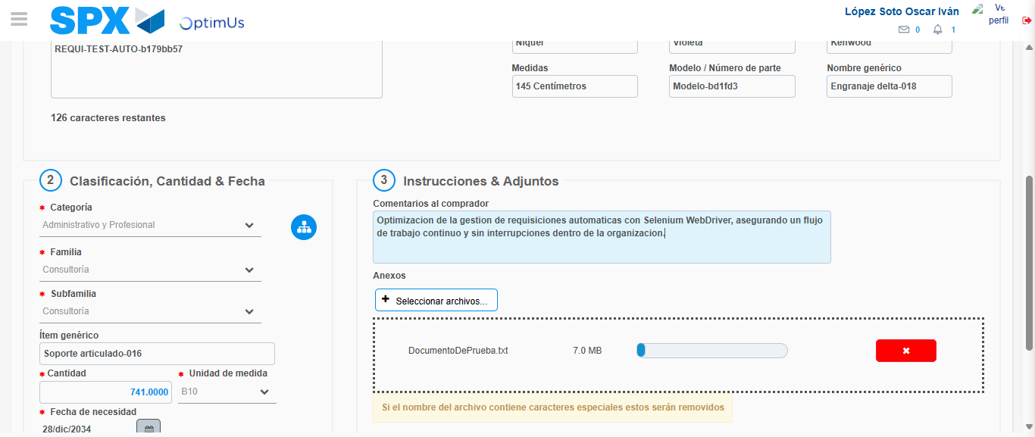Image file-name: QC_Testing-tc005_SPX_Dev5_Crear_Requisicion_Spot_Con_FAD_Tipo_Cobro_Project-1784653253977

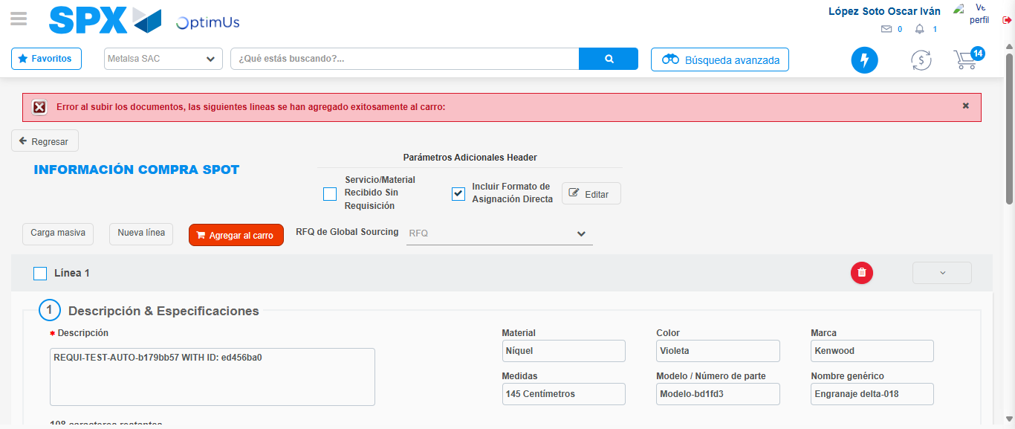Image file-name: QC_Testing-tc005_SPX_Dev5_Crear_Requisicion_Spot_Con_FAD_Tipo_Cobro_Project-1784653262665

Step 8 - Return to Main Page SPX : Return to Main Page SPX
Image file-name: QC_Testing-tc005_SPX_Dev5_Crear_Requisicion_Spot_Con_FAD_Tipo_Cobro_Project-1784653192868

Image file-name: QC_Testing-tc005_SPX_Dev5_Crear_Requisicion_Spot_Con_FAD_Tipo_Cobro_Project-1784653206011

Image file-name: QC_Testing-tc005_SPX_Dev5_Crear_Requisicion_Spot_Con_FAD_Tipo_Cobro_Project-1784653215352

Image file-name: QC_Testing-tc005_SPX_Dev5_Crear_Requisicion_Spot_Con_FAD_Tipo_Cobro_Project-1784653264936

Image file-name: QC_Testing-tc005_SPX_Dev5_Crear_Requisicion_Spot_Con_FAD_Tipo_Cobro_Project-1784653265154

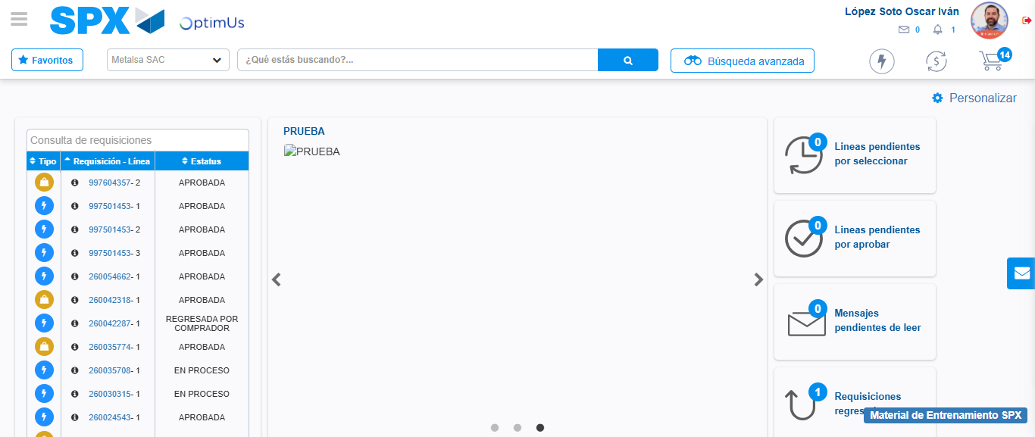Image file-name: QC_Testing-tc005_SPX_Dev5_Crear_Requisicion_Spot_Con_FAD_Tipo_Cobro_Project-1784653286394

Step 9 - Log Out : Log Out SPX
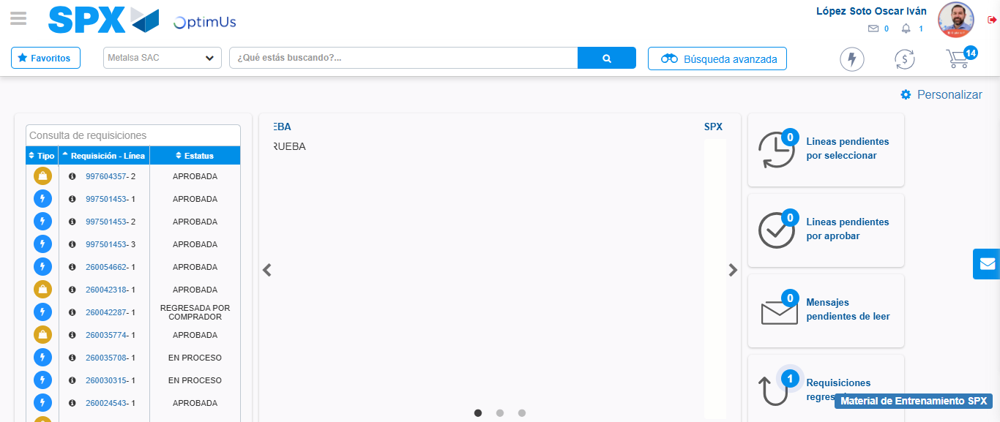Image file-name: QC_Testing-tc005_SPX_Dev5_Crear_Requisicion_Spot_Con_FAD_Tipo_Cobro_Project-1784653286729

